63.07.07
Transfer of Title
archival locaton?, SA.

[South Australia.
(A)
APPLICATION TO BRING LANDS UNDER THE PROVISIONS OF THE REAL PROPERTY ACT OF 1861.
I, Louis Almers of Adelaide in the Province of South Australia, butcher do declare that I am seised of an estate of freehold in fee simple in all that piece of land situated in the the Village of Tanunda, being the allotment numbered “11” containing one acre or thereabouts, bounded as appears by plan in the margin hereof and therein coloured red

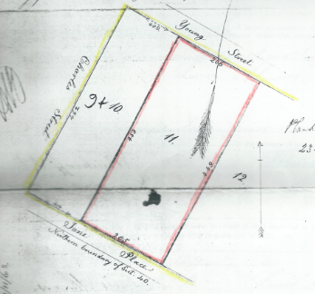

which piece of land is of the value of Sixteen Pounds Sterling and no more, and is part of the Country Section of land originally granted to by land grant, under the hand and seal of of the Province of South Australia, dated the day of , numbered 39 in the plan of the said Hundred of Moorooroo as delineated on the public maps of the Province deposited in the Survey Office in Adelaide: And I do further declare that I am not aware of any mortgage, encumbrance, or claim affecting the said lands, or that any person hath any claim, estate, or interest in the said lands at law or in equity, in possession or in expectancy, other than is set forth and stated as follows, that is to say—
That I have sold the said piece of land to Ferdinand Jacob Heinrich Müller of Melbourne in the Province of Victoria Esqre M.D. Ph.D.
And I further declare there is no person in possession or occupation of the said lands adversely to my estate or interest therein, and that the said land is now in the occupation of Carl von Bertouch and that Thomas Smith and – Lutze and other trustees are owners of contiguous land and that there are no deeds or instruments of title affecting such land in my possession or under my control, other than those enumerated in the Schedule hereto: And I made this solemn declaration, conscientiously believing the same to be true.
Dated at Adelaide this seventh day of July 1863.
Louis Almers

Made and subscribed by the above-named Louis Almers on this seventh day of July in the presence of me
F. Krichauff J. P.

I, Louis Almers the above declarant, do hereby apply to have the piece of land described in the above declaration brought under the provisions of the Real Property Act of 1861.
Dated at Adelaide this seventh day of July 1863.
Louis Almers

Witness to signature–
F. E. Krichauff J. P.

To the Registrar-General–
I, the above-named declarant, hereby request you to issue the Certificate of Title for the above mentioned piece of land, in the name of Ferdinand Jacob Heinrich Müller Doctor of Philosophy and of Medicine, Melbourne
Louis Almers

Witness to signature
F. E. Krichauff J. P.

[This application is correct for the purposes of the Real Property Act.]
F. E. Krichauff
Lic. Broker

SCHEDULE REFERRED TO.
Conveyance Charles Flaxman to Louis Almers dated June 22nd 1848.

63-07-07_image01.jpg
Several spaces in the sentence that follows have not been filled in.
Marginal annotations: 'Certificate issued Vol: XLV Folio 194 13/11/63' and 'I consent hereto John B. [Speng] official [...]'. 'Witness to signature F. Krichauff J. P.' See also Transfer of Title, 15 December 1865 (in this edition as 65-12-15b).

